**Project 2: Electric Potential Beau G.**

**Date: 4/3/2019**

**Introduction**

The goal of this project was to compare the effectiveness of two different solution methods in solving for the electric potential in a 2-D region containing oppositely charged parallel plates. Those methods being the Jacobi method and Simultaneous Over-Relaxation (SOR) method. In order to achieve that goal it was required to implement those two methods correctly in relation to the problem presented, as well as perform analysis of the results done by creating plots of key information taken from the program.

**Part (A): Hypothesis of Electric Field Behavior**

The first task was to contemplate what the electric field would behave like in the initial conditions. I hypothesize that the electric field in the initial conditions will flow from the positive potential plate to the negative potential plate (in our initial setup this would be a flow from right plate to left plate) because of the natural flow from high potential to low potential. There will also be a flow away from the positive plate (toward lower potentials) and toward the negative plate on the outer edges of the region. As these plates are brought closer together, I expect for the electric field to become stronger as the formula for the strength of the electric field is proportional to $\frac{1}{d}$, ‘d’ being the distance between the two plates. From this relationship it’s clear that as the distance is decreased, the overall strength of the electric field will increase.

**Part (B): Implementing Numerical Methods**

The numerical methods for solving for the electric potential using the Jacobi method and SOR method will be attached in a python script. The methods are basic implementations of each method with slight modifications in order to keep track of important information needed for analysis and comparison. The modifications used include using a timer to calculate runtime of each method call as well as an iteration counter used to keep track of how many iterations the program goes through in order to reach convergence.

**Part (C): Optimal Relaxation Value**

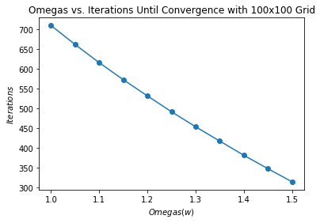In order to perform analysis using the SOR method, we were first tasked to find the optimal values for the relaxation variable *w*. The task presented was to test *w* values ranging from 1 to 1.5 and see which resulted in the most effective calculation. In order determine which value was optimal it’s important to specify by what standards is it the most optimal. I used the amount of iterations until convergence as my deciding factor on which value was the most optimal. For the test I used values from 1 to 1.5 incrementing by 0.05 with 100 being the number of grid spaces along each side of the 2-D region. The following plot shows the results of this test.

From analyzing the plot, it is clear that the optimal value in the tested range is 1.5 as it resulted in the least amount of iterations until convergence (1.5 also resulted in the least amount of runtime). This result is what was to be expected as in our textbook it states that *w* = 1.9 is the value which ends in the best results for using SOR.

**Part (D): Scaling of Convergence – Jacobi vs. SOR**

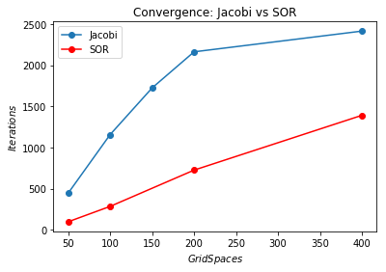Now that the optimal value has been determined, we can begin testing the convergence of the Jacobi method and the SOR method using different grid sizes. The sizes required to be tested were 50x50, 100x100, 200x200, and 400x400. The following plot shows the results of the convergence testing.

The expectation for the convergence behavior for both methods is a linear relationship between grid size and number of iterations until convergence and SOR running in less iterations then Jacobi. From the plot it is easy to see that the SOR has a practically linear behavior and runs in less iterations than the Jacobi therefore agreeing with the expectations. The test for the Jacobi method came out with interesting results. Up until a 200x200 grid size the method follows a rather linear behavior but between 200x200 and 400x400 it quickly begins to become asymptotic to a certain point. Because this behavior does not agree with the expectations, extra tests were ran with more grid sizes. Using a 150x150 grid size fell in with the less than 200x200 trend of being linear but when tests were ran with 250x250 and 300x300, both showed immediate asymptotic behavior. After analyzing the numerical method for the Jacobi, I was unable to discover the reason as to why this behavior happens at any grid sizes greater than 200x200. Other than those outlier values, there is an overall agreement with the expected behavior between the Jacobi and SOR methods.

**Part (E): Analysis of Electric Field (Using SOR)**

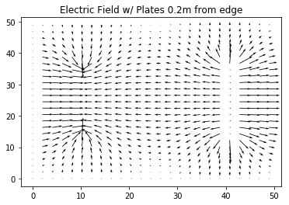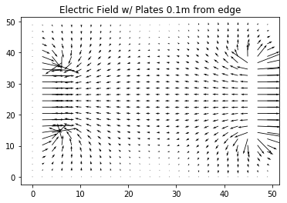The last task was to use the potential values from the SOR calculation to calculate the values for the electric field and create a quiver plot of those values in order to analyze the behavior of the electric field and compare it to the hypothesized behavior. The values for the electric field were calculated using the equation E = -∇ϕ where ϕ is the potential values. Once the electric field values were calculated we were able to plot and analyze the behavior. The following plots show the electric field for four different cases, each with a different separation distance between the two plates.

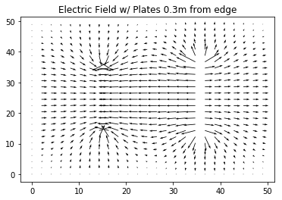

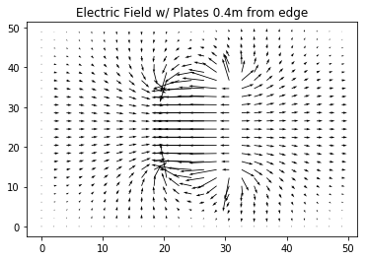

The plots show that in-between the two plates the field flows from high potential to low potential. It also shows that in the outer regions the field flows away from the high potential plate and toward the low potential plate. These results agree with hypothesized behavior of the initial conditions. When the conditions are changed, specifically the separation distance of the two plates, it’s shown that the vectors between the two plates get longer which in the quiver plot represents the strength of the field. Therefore as hypothesized, when the plates are brought closer together the electric field between the two plates grows stronger.

**Conclusion**

Overall, from the tests performed there was agreement to the expectations. In the case of the scaling of the convergence of Jacobi and SOR methods, the behavior of the SOR and the expected behavior of the SOR agreed very well and there was partial agreement on the behavior of the Jacobi due to its linear-like behavior to start but because of its asymptotic behavior at higher grid values it falls from expectation. When comparing hypothesized behavior to actual behavior of the electric field, there was very good agreement. The behavior of the field was as expected and the relationship between the distance between the plates and the strength of the electric field also agreed with expectations.